## Arrays Quiz 1

**What will be the output of the code given bellow?**

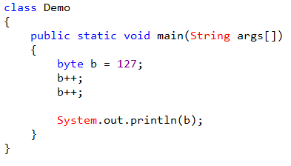

Choose only ONE best answer.

**A**

129

**B**

-127

**C**

Error

**D**

128

**The correct answer is 'B'**

byte range is from -128 to 127, b value has been initialized with 127.

In the next step b value is incremented so it will go in the cyclic order so now b value is -128, again b value is incremented thus final b value is -127.

**What will be the output of the code given bellow?**

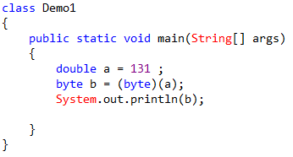

Choose only ONE best answer.

**A**

-125

**B**

125

**C**

-131

**D**

126

**The correct answer is 'A'**a is assigned with the value 131 which is of type double, in the next step it is type casted to byte as byte ranges from -128 to 127 to reach 131 from 127 still 4more counts required so after 127 it will go in a cyclic order and starts counting from -128 thus the output of the above code is -125.

**Predict the output of the code given bellow?**

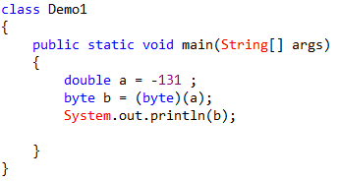

Choose only ONE best answer.

**A**

125

**B**

-125

**C**

126

**D**

131

**The correct answer is 'A'**a is assigned with the value -131 which is of type double, in the next step it is type casted to byte as byte ranges from -128 to 127 to reach 131 from -128 still 3more counts required so after -128 it will go in a cyclic order and starts counting from 127 thus the output of the above code is 125.

**Wrapper classes are not used to convert any data type into an object.**

Choose only ONE best answer.

**A**

TRUE

**B**

False

**The correct answer is 'B'**

**Void is not a wrapper class**

Choose only ONE best answer.

**A**

TRUE

**B**

FALSE

**The correct answer is 'A'**

**What package is a part of the wrapper class which is imported by default into all Java programs?**

Choose only ONE best answer.

**A**

java.lang

**B**

java.awt

**C**

java.io

**D**

java.util

**The correct answer is 'A'**

**Consider the following two statements int x = 25; Integer y = new Integer(33); What is the difference between these two statements?**

Choose only ONE best answer.

**A**

Primitive data types

**B**

primitive data type and an object of a wrapper class

**C**

Wrapper class

**D**

None of the above

**The correct answer is 'B'**

**Where does the primitive data type values be stored?**

Choose only ONE best answer.

**A**

Heap Memory

**B**

Stack Memory

**C**

Both A & B

**D**

None of the above

**The correct answer is 'B'**

**What will be the output of the following Java program?**

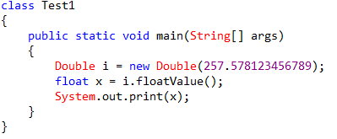

Choose only ONE best answer.

**A**

0

**B**

1

**C**

257.57812

**D**

257. 578123456789

**The correct answer is 'C'**floatValue() converts the value of wrapper i into float, since float can measure till 5 places after decimal hence 257.57812 is stored in floating point variable x.

**Array is a sequential collection of:**

Choose only ONE best answer.

**A**

Similar data type

**B**

Different data type

**C**

functions

**D**

None of the mentioned

**The correct answer is 'A'**